UNIT – II

Radiation Fundamentals:

**Antenna:** An Antenna is a transducer, which converts electrical power into electromagnetic waves and vice versa.

An Antenna can be used either as a **transmitting antenna** or a **receiving antenna**.

* A **transmitting antenna** is one, which converts electrical signals into electromagnetic waves and radiates them.
* A **receiving antenna** is one, which converts electromagnetic waves from the received beam into electrical signals.
* In two-way communication, the same antenna can be used for both transmission and reception.

Antenna can also be termed as an **Aerial**.

**Radiation Mechanism**

The sole functionality of an antenna is **power radiation** or reception. Antenna (whether it transmits or receives or does both) can be connected to the circuitry at the station through a transmission line. The functioning of an antenna depends upon the radiation mechanism of a transmission line.

A conductor, which is designed to carry current over large distances with minimum losses, is termed as a **transmission line**. For example, a wire, which is connected to an antenna. A transmission line conducting current with uniform velocity, and the line being a straight one with infinite extent, **radiates no power**.

For a transmission line, to become a waveguide or to radiate power, has to be processed as such.

* If the power has to be radiated, though the current conduction is with uniform velocity, the wire or transmission line should be bent, truncated or terminated.
* If this transmission line has current, which accelerates or decelerates with a timevarying constant, then it radiates the power even though the wire is straight.
* The device or tube, if bent or terminated to radiate energy, then it is called as **waveguide**. These are especially used for the microwave transmission or reception.

This can be well understood by observing the following diagram −

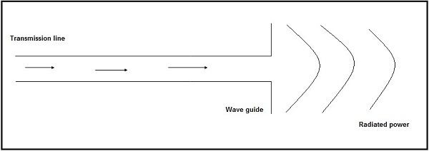

The above diagram represents a waveguide, which acts as an antenna. The power from the transmission line travels through the waveguide which has an aperture, to radiate the energy.

## Basic Types of Antennas

Antennas may be divided into various types depending upon −

* The physical structure of the antenna.
* The frequency ranges of operation.
* The mode of applications etc.

### Physical structure

Following are the types of antennas according to the physical structure. You will learn about these antennas in later chapters.

* Wire antennas
* Aperture antennas
* Reflector antennas
* Lens antennas
* Micro strip antennas
* Array antennas

### Frequency of operation

Following are the types of antennas according to the frequency of operation.

* Very Low Frequency (VLF)
* Low Frequency (LF)
* Medium Frequency (MF)
* High Frequency (HF)
* Very High Frequency (VHF)
* Ultra High Frequency (UHF)
* Super High Frequency (SHF)
* Micro wave
* Radio wave

### Mode of Applications

Following are the types of antennas according to the modes of applications −

* Point-to-point communications
* Broadcasting applications
* Radar communications
* Satellite communications

## Directivity

According to the standard definition, “The ratio of maximum radiation intensity of the subject antenna to the radiation intensity of an isotropic or reference antenna, radiating the same total power is called the **directivity**.”

An Antenna radiates power, but the direction in which it radiates matters much. The antenna, whose performance is being observed, is termed as **subject antenna**.

Its **radiation intensity** is focused in a particular direction, while it is transmitting or receiving. Hence, the antenna is said to have its **directivity** in that particular direction.

* The ratio of radiation intensity in a given direction from an antenna to the radiation intensity averaged over all directions, is termed as directivity.
* If that particular direction is not specified, then the direction in which maximum intensity is observed, can be taken as the directivity of that antenna.
* The directivity of a non-isotropic antenna is equal to the ratio of the radiation intensity in a given direction to the radiation intensity of the isotropic source.

### Mathematical Expression

The radiated power is a function of the angular position and the radial distance from the circuit. Hence, it is expressed by considering both the terms **θ** and **Ø**.

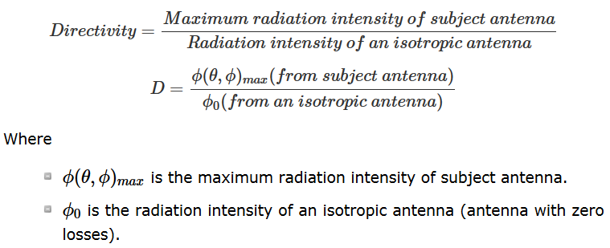

## Aperture Efficiency

According to the standard definition, “**Aperture efficiency** of an antenna, is the ratio of the effective radiating area (or effective area) to the physical area of the aperture.”

An antenna has an aperture through which the power is radiated. This radiation should be effective with minimum losses. The physical area of the aperture should also be taken into consideration, as the effectiveness of the radiation depends upon the area of the aperture, physically on the antenna.

### Mathematical Expression

The mathematical expression for aperture efficiency is as follows −

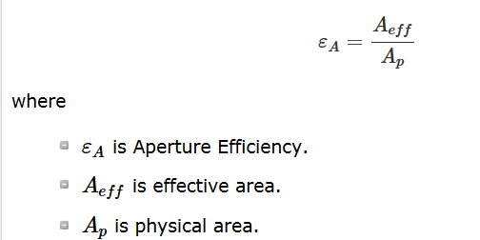

## Antenna Efficiency

According to the standard definition, “**Antenna Efficiency** is the ratio of the radiated power of the antenna to the input power accepted by the antenna.”

Simply, an Antenna is meant to radiate power given at its input, with minimum losses. The efficiency of an antenna explains how much an antenna is able to deliver its output effectively with minimum losses in the transmission line.

This is otherwise called as **Radiation Efficiency Factor** of the antenna.

### Mathematical Expression

The mathematical expression for antenna efficiency is given below −

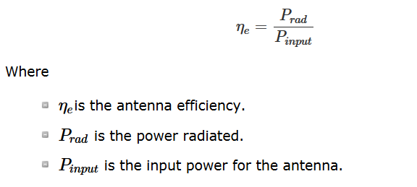

## Gain

According to the standard definition, “**Gain** of an antenna is the ratio of the radiation intensity in a given direction to the radiation intensity that would be obtained if the power accepted by the antenna were radiated isotropically.”

Simply, gain of an antenna takes the directivity of antenna into account along with its effective performance. If the power accepted by the antenna was radiated isotropically (that means in all directions), then the radiation intensity we get can be taken as a referential.

* The term **antenna gain** describes how much power is transmitted in the direction of peak radiation to that of an isotropic source.
* **Gain** is usually measured in **dB**.
* Unlike directivity, antenna gain takes the losses that occur also into account and hence focuses on the efficiency.

### Mathematical Expression

The equation of gain, G is as shown below.

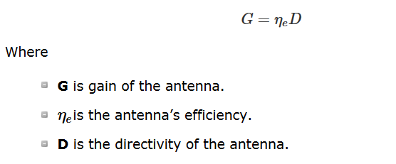

### Units

The unit of gain is **decibels** or simply **dB**.

**Near field and the far field regions of the antenna:**

The radiation intensity when measured nearer to the antenna, differs from what is away from the antenna. Though the area is away from the antenna, it is considered effective, as the radiation intensity is still high there.

### Near Field

The field, which is nearer to the antenna, is called as **near-field**. It has an inductive effect and hence it is also known as **inductive field**, though it has some radiation components.

### Far field

The field, which is far from the antenna, is called as **far-field**. It is also called as **radiation field**, as the radiation effect is high in this area. Many of the antenna parameters along with the antenna directivity and the radiation pattern of the antenna are considered in this region only.

## Field Pattern

The field distribution can be quantifying in terms of field intensity is referred to as field pattern. That means, the radiated power from the antenna when plotted, is expressed in terms of electric field, E (v/m). Hence, it is known as **field pattern**. If it is quantified in terms of power (W), then it is known as **power pattern**.

The graphical distribution of radiated field or power will be as a function of

* spatial angles (θ, Ø) for far-field.
* spatial angles (θ, Ø) and radial distance(r) for near-field.

The distribution of near and far field regions can be well understood with the help of a diagram.

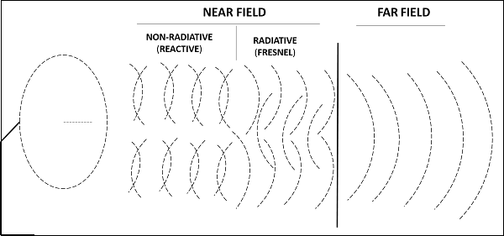

The field pattern can be classified as −

* Reactive near-field region and Radiating near-field region – both termed as nearfield.
* Radiating far-field region – simply called as far-field.

The field, which is very near to the antenna is **reactive near field** or **non-radiative field** where the radiation is not pre-dominant. The region next to it can be termed as **radiating near field** or **Fresnel’s field** as the radiation predominates and the angular field distribution, depends on the physical distance from the antenna.

The region next to it is **radiating far-field** region. In this region, field distribution is independent of the distance from antenna. The effective radiation pattern is observed in this region.

Radiation is the term used to represent the emission or reception of wave front at the antenna, specifying its strength. In any illustration, the sketch drawn to represent the radiation of an antenna is its **radiation pattern**. One can simply understand the function and directivity of an antenna by having a look at its radiation pattern.

The power when radiated from the antenna has its effect in the near and far field regions.

* Graphically, radiation can be plotted as a function of **angular position** and **radial distance** from the antenna.
* This is a mathematical function of radiation properties of the antenna represented as a function of spherical co-ordinates, E (θ, Ø) and H (θ, Ø).

## Radiation Pattern

The energy radiated by an antenna is represented by the **Radiation pattern** of the antenna. Radiation Patterns are diagrammatical representations of the distribution of radiated energy into space, as a function of direction.

Let us look at the pattern of energy radiation.

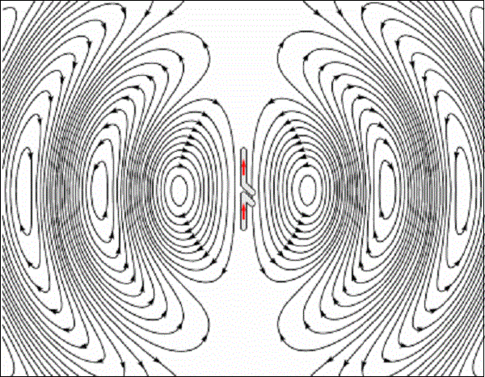

The figure given above shows radiation pattern of a dipole antenna. The energy being radiated is represented by the patterns drawn in a particular direction. The arrows represent directions of radiation.

The radiation patterns can be field patterns or power patterns.

* The **field patterns** are plotted as a function of electric and magnetic fields. They are plotted on logarithmic scale.
* The **power patterns** are plotted as a function of square of the magnitude of electric and magnetic fields. They are plotted on logarithmic or commonly on dB scale.

### Radiation Pattern in 3D

The radiation pattern is a three-dimensional figure and represented in spherical coordinates (r, θ, Φ) assuming its origin at the center of spherical coordinate system. It looks like the following figure −

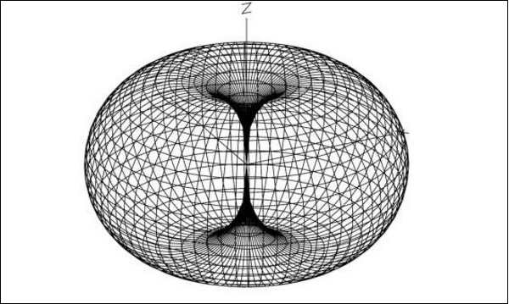

The given figure is a three dimensional radiation pattern for an **Omni directional pattern**. This clearly indicates the three co-ordinates (x, y, z).

### Radiation Pattern in 2D

Two-dimensional pattern can be obtained from three-dimensional pattern by dividing it into horizontal and vertical planes. These resultant patterns are known as **Horizontal pattern** and **Vertical pattern** respectively.

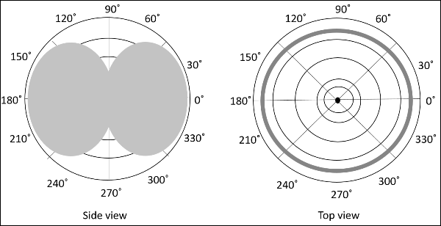

The figures show the Omni directional radiation pattern in H and V planes as explained above. H-plane represents the Horizontal pattern, whereas V-plane represents the Vertical pattern.

### Lobe Formation

In the representation of radiation pattern, we often come across different shapes, which indicate the major and minor radiation areas, by which the **radiation efficiency** of the antenna is known.

To have a better understanding, consider the following figure, which represents the radiation pattern of a dipole antenna.

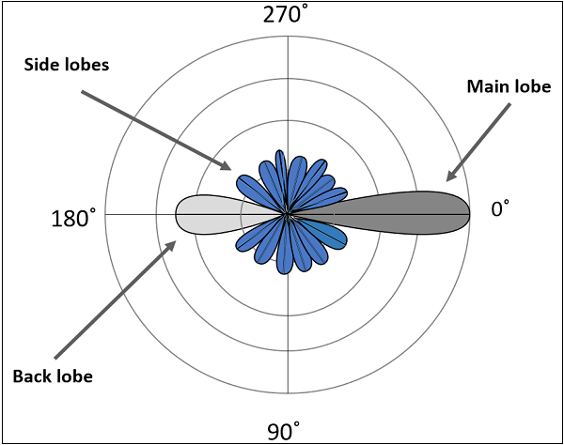

Here, the radiation pattern has main lobe, side lobes and back lobe.

* The major part of the radiated field, which covers a larger area, is the **main lobe** or **major lobe**. This is the portion where maximum radiated energy exists. The direction of this lobe indicates the directivity of the antenna.
* The other parts of the pattern where the radiation is distributed side wards are known as **side lobes** or **minor lobes**. These are the areas where the power is wasted.
* There is other lobe, which is exactly opposite to the direction of main lobe. It is known as **back lobe**, which is also a minor lobe. A considerable amount of energy is wasted even here.

### Example

If the antennas used in radar systems produce side lobes, target tracing becomes very difficult. This is because, false targets are indicated by these side lobes. It is messy to trace out the real ones and to identify the fake ones. Hence, **elimination** of these **side lobes** is must, in order to improve the performance and save the energy.

### Remedy

The radiated energy, which is being wasted in such forms needs to be utilized. If these minor lobes are eliminated and this energy is diverted into one direction (that is towards the major lobe), then the **directivity** of the antenna gets increased which leads to antenna’s better performance.

### Types of Radiation patterns

The common types of Radiation patterns are −

* Omni-directional pattern (also called non-directional pattern): The pattern usually has a doughnut shape in three-dimensional view. However, in two-dimensional view, it forms a figure-of-eight pattern.
* Pencil-beam pattern − The beam has a sharp directional pencil shaped pattern.
* Fan-beam pattern − The beam has a fan-shaped pattern.
* Shaped beam pattern − The beam, which is non-uniform and patternless is known as shaped beam.

A referential point for all these types of radiation is the isotropic radiation. It is important to consider the isotropic radiation even though it is impractical.

**Isotropic radiation** is the radiation from a point source, radiating uniformly in all directions, with same intensity regardless of the direction of measurement.

The improvement of radiation pattern of an antenna is always assessed using the isotropic radiation of that antenna. If the radiation is equal in all directions, then it is known as **isotropic radiation**.

* The point source is an example of isotropic radiator. However, this isotropic radiation is practically impossible, because every antenna radiates its energy with some directivity.
* The isotropic radiation is nothing but **Omni-directional radiation**.
* It has a doughnut-shaped pattern when viewed in 3D and a figure-of-eight pattern when viewed in 2D.

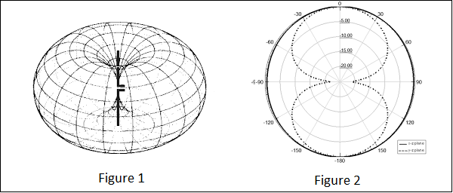

The figures given above show the radiation pattern of an isotropic or Omni-directional pattern. Figure 1 illustrates the doughnut shaped pattern in 3D and Figure 2 illustrates the figure-of-eight pattern in 2D.

### Gain

The isotropic radiator has unity gain, which means having a gain factor of 1 in all directions. In terms of dB, it can be called as 0dB gain (zero loss).

## Equivalent Isotropic Radiated Power

According to the standard definition, “The amount of power that an isotropical antenna radiates to produce the peak power density observed in the direction of maximum antenna gain, is called as **Equivalent Isotropic Radiated Power**.”

If the radiated energy of an antenna is made to concentrate on one side or a particular direction, where the radiation is equivalent to that antenna’s isotropic radiated power, such a radiation would be termed as EIRP i.e. Equivalent Isotropic Radiated Power.

### Gain

Though isotropic radiation is an imaginary one, it is the best an antenna can give. The gain of such antenna will be 3dBi where 3dB is a factor of 2 and ‘i’ represents factor of isotropic condition.

If the radiation is focused in certain angle, then EIRP increases along with the antenna gain. Gain of the antenna is best achieved by focusing the antenna in certain direction.

## Effective Radiated Power

If the radiated power is calculated by taking half-wave dipole as the reference, rather than an isotropic antenna, then it can be termed as **ERP (Effective Radiated Power)**.

*ERP*(*dBW*)=*EIRP*(*dBW*)−2.15*dBi*

## Beam Area

According to the standard definition, “Beam area is the solid angle through which all the power radiated by the antenna would stream if P (θ, Ø) maintained its maximum value over ΩA and was zero elsewhere.”

The radiated beam of the antenna comes out from an angle at the antenna, known as solid angle, where the power radiation intensity is maximum. This **solid beam angle** is termed as the **beam area**. It is represented by **ΩA**.

The radiation intensity P (θ, Ø) should be maintained constant and maximum throughout the solid beam angle ΩA, its value being zero elsewhere.

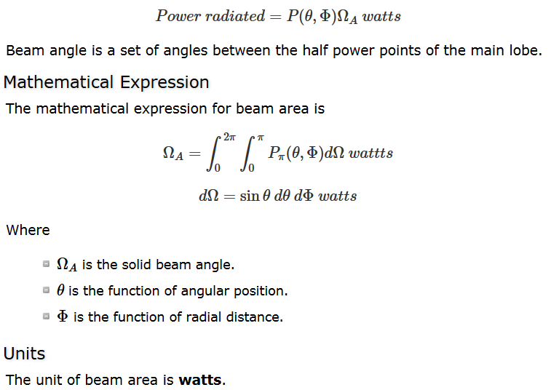

## Beam Efficiency

According to the standard definition, “The **beam efficiency** states the ratio of the beam area of the main beam to the total beam area radiated.”

The energy when radiated from an antenna, is projected according to the antenna’s directivity. The direction in which an antenna radiates more power has maximum efficiency, while some of the energy is lost in side lobes. The maximum energy radiated by the beam, with minimum losses can be termed as **beam efficiency**.

### Mathematical Expression

The mathematical expression for beam efficiency is −

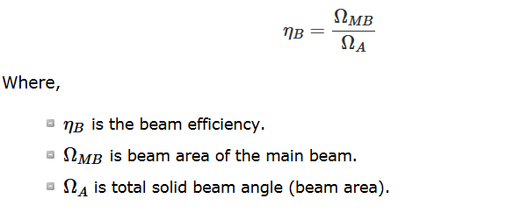

## Antenna Polarization

An Antenna can be polarized depending upon our requirement. It can be linearly polarized or circularly polarized. The type of antenna polarization decides the pattern of the beam and polarization at the reception or transmission.

### Linear polarization

When a wave is transmitted or received, it may be done in different directions. The **linear polarization**of the antenna helps in maintaining the wave in a particular direction, avoiding all the other directions. Though this linear polarization is used, the electric field vector stays in the same plane. Hence, we use this linear polarization to improve the **directivity** of the antenna.

### Circular polarization

When a wave is circularly polarized, the electric field vector appears to be rotated with all its components loosing orientation. The mode of rotation may also be different at times. However, by using **circular polarization**, the effect of multi-path gets reduced and hence it is used in satellite communications such as **GPS**.

### Horizontal polarization

Horizontal polarization makes the wave weak, as the reflections from the earth surface affect it. They are usually weak at low frequencies below 1GHz. **Horizontal polarization** is used in the transmission of **TV signals** to achieve a better signal to noise ratio.

### Vertical polarization

The low frequency vertically polarized waves are advantageous for ground wave transmission. These are not affected by the surface reflections like the horizontally polarized ones. Hence, the **vertical polarization** is used for **mobile communications**.

Each type of polarization has its own advantages and disadvantages. A RF system designer is free to select the type of polarization, according to the system requirements.

## Half-Power Beam Width

According to the standard definition, “The angular separation, in which the magnitude of the radiation pattern decreases by 50% (or -3dB) from the peak of the main beam, is the **Half Power Beam Width**.”

In other words, Beam width is the area where most of the power is radiated, which is the peak power. **Half power beam width** is the angle in which relative power is more than 50% of the peak power, in the effective radiated field of the antenna.

### Indication of HPBW

When a line is drawn between radiation pattern’s origin and the half power points on the major lobe, on both the sides, the angle between those two vectors is termed as **HPBW**, half power beam width. This can be well understood with the help of the following diagram.

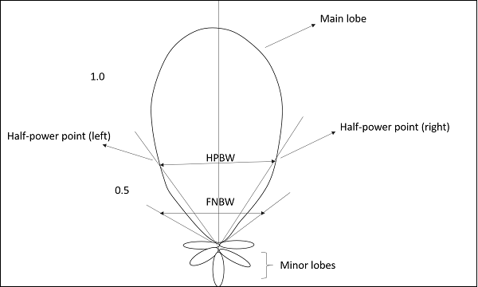

The figure shows half-power points on the major lobe and HPBW.

### Mathematical Expression

The mathematical expression for half power beam width is −

*HalfpowerBeamwith*=70*λ*/*D*

Where

* *λ*
* is wavelength (λ = 0.3/frequency).
* **D** is Diameter.

### Units

The unit of HPBW is **radians** or **degrees**.

## First Null Beam Width

According to the standard definition, “The angular span between the first pattern nulls adjacent to the main lobe, is called as the **First Null Beam Width**.”

Simply, FNBW is the angular separation, quoted away from the main beam, which is drawn between the null points of radiation pattern, on its major lobe.

### Indication of FNBW

Draw tangents on both sides starting from the origin of the radiation pattern, tangential to the main beam. The angle between those two tangents is known as First Null Beam Width **(FNBW)**.

This can be better understood with the help of the following diagram.

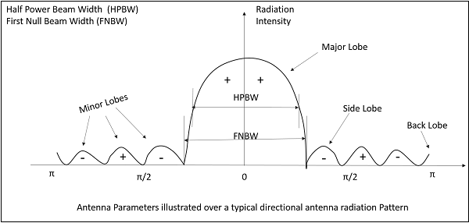

The above image shows the half power beam width and first null beam width, marked in a radiation pattern along with minor and major lobes.

### Mathematical Expression

The mathematical expression of First Null Beam Width is

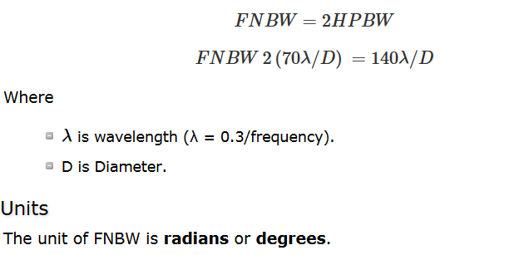

## Effective Length & Effective Area

Among the antenna parameters, the effective length and effective area are also important. These parameters help us to know about the antenna’s performance.

### Effective length

Antenna Effective length is used to determine the polarization efficiency of the antenna.

**Definition**− “The **Effective length** is the ratio of the magnitude of voltage at the open terminals of the receiving antenna to the magnitude of the field strength of the incident wave front, in the same direction of antenna polarization.”

When an incident wave arrives at the antenna’s input terminals, this wave has some field strength, whose magnitude depends upon the antenna’s polarization. This polarization should match with the magnitude of the voltage at receiver terminals.

### Mathematical Expression

The mathematical expression for effective length is −

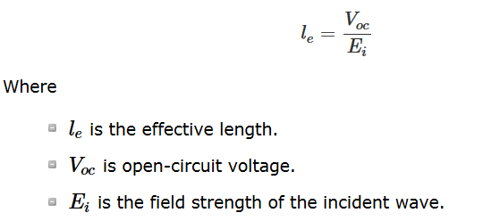

### Effective area

**Definition** − “**Effective area** is the area of the receiving antenna, which absorbs most of the power from the incoming wave front, to the total area of the antenna, which is exposed to the wave front.”

The whole area of an antenna while receiving, confronts the incoming electromagnetic waves, whereas only some portion of the antenna, receives the signal, known as the **effective area**.

Only some portion of the received wave front is utilized because some portion of the wave gets scattered while some gets dissipated as heat. Hence, without considering the losses, the area, which utilizes the maximum power obtained to the actual area, can be termed as **effective area**.

Effective area is represented by *Aeff*.

## Properties under Reciprocity

The properties of transmitting and receiving antenna that exhibit the reciprocity are −

* Equality of Directional patterns.
* Equality of Directivities.
* Equality of Effective lengths.
* Equality of Antenna impedances.

Let us see how these are implemented.

### Equality of Directional patterns

The **radiation pattern** of transmitting antenna1, which transmits to the receiving antenna2 is equal to the radiation pattern of antenna2, if it transmits and antenna1 receives the signal.

### Equality of Directivities

**Directivity** is same for both transmitting and receiving antennas, if the value of directivity is same for both the cases i.e. the directivities are same whether calculated from transmitting antenna’s power or receiving antenna’s power.

### Equality of Effective lengths

The value of maximum effective aperture is same for both transmitting and receiving antennas. **Equality** in the **lengths** of both transmitting and receiving antennas is maintained according to the value of the wavelength.

### Equality in Antenna Impedances

The output impedance of a transmitting antenna and the input impedance of a receiving antenna are equal in an effective communication.

These properties will not change though the same antenna is operated as a transmitter or as a receiver. Hence, the **property of reciprocity** is followed.

**Type of antenna** :

Antennas have to be classified to understand their physical structure and functionality more clearly. There are many types of antennas depending upon the applications applications.

|  |  |  |
| --- | --- | --- |
| **Type of antenna** | **Examples** | **Applications** |
| Wire Antennas | Dipole antenna, Monopole antenna, Helix antenna, Loop antenna | Personal applications, buildings, ships, automobiles, space crafts |
| Aperture Antennas | Waveguide (opening), Horn antenna | Flush-mounted applications, air-craft, space craft |
| Reflector Antennas | Parabolic reflectors, Corner reflectors | Microwave communication, satellite tracking, radio astronomy |
| Lens Antennas | Convex-plane, Concave-plane, Convex-convex, Concaveconcave lenses | Used for very highfrequency applications |
| Micro strip Antennas | Circular-shaped, Rectangularshaped metallic patch above the ground plane | Air-craft, space-craft, satellites, missiles, cars, mobile phones etc. |
| Array Antennas | Yagi-Uda antenna, Micro strip patch array, Aperture array, Slotted wave guide array | Used for very high gain applications, mostly when needs to control the radiation pattern |

**Half-wave Dipole :**

The dipole antenna is cut and bent for effective radiation. The length of the total wire, which is being used as a dipole, equals half of the wavelength (i.e., l = λ/2). Such an antenna is called as **half-wave dipole antenna**. This is the most widely used antenna because of its advantages. It is also known as **Hertz antenna**.

### Frequency range

The range of frequency in which half-wave dipole operates is around 3KHz to 300GHz. This is mostly used in radio receivers.

## Construction & Working of Half-wave Dipole

It is a normal dipole antenna, where the frequency of its operation is **half of its wavelength**. Hence, it is called as half-wave dipole antenna.

The edge of the dipole has maximum voltage. This voltage is alternating (AC) in nature. At the positive peak of the voltage, the electrons tend to move in one direction and at the negative peak, the electrons move in the other direction. This can be explained by the figures given below.

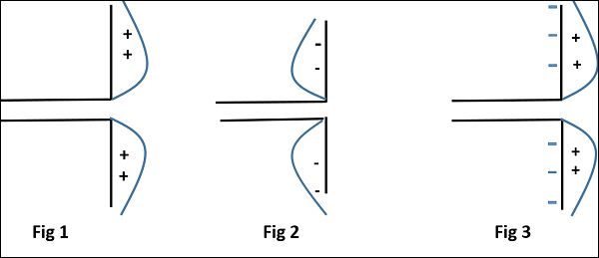

The figures given above show the working of a half-wave dipole.

* Fig 1 shows the dipole when the charges induced are in positive half cycle. Now the electrons tend to move towards the charge.
* Fig 2 shows the dipole with negative charges induced. The electrons here tend to move away from the dipole.
* Fig 3 shows the dipole with next positive half cycle. Hence, the electrons again move towards the charge.

The cumulative effect of this produces a varying field effect which gets radiated in the same pattern produced on it. Hence, the output would be an effective radiation following the cycles of the output voltage pattern. Thus, a half-wave dipole **radiates effectively**.

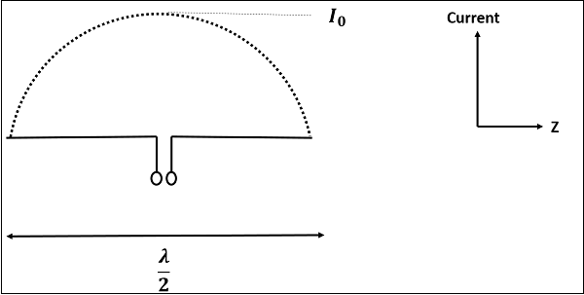

The above figure shows the current distribution in half wave dipole. The directivity of half wave dipole is 2.15dBi, which is reasonably good. Where, ‘i’ represents the isotropic radiation.

## Radiation Pattern

The radiation pattern of this half-wave dipole is **Omni-directional** in the H-plane. It is desirable for many applications such as mobile communications, radio receivers etc.

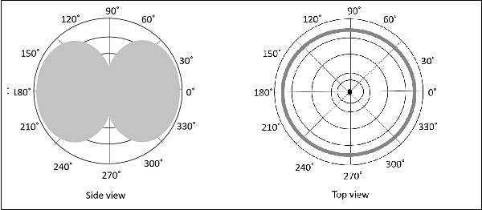

The above figure indicates the radiation pattern of a half wave dipole in both H-plane and V-plane.

The radius of the dipole does not affect its input impedance in this half wave dipole, because the length of this dipole is half wave and it is the first resonant length. An antenna works effectively at its **resonant frequency**, which occurs at its resonant length.

### Advantages

The following are the advantages of half-wave dipole antenna −

* Input impedance is not sensitive.
* Matches well with transmission line impedance.
* Has reasonable length.
* Length of the antenna matches with size and directivity.

### Disadvantages

The following are the disadvantages of half-wave dipole antenna −

* Not much effective due to single element.
* It can work better only with a combination.

### Applications

The following are the applications of half-wave dipole antenna −

* Used in radio receivers.
* Used in television receivers.
* When employed with others, used for wide variety of applications.

**Short Dipole :**

A **short dipole** is a simple wire antenna. One end of it is open-circuited and the other end is fed with AC source. This dipole got its name because of its length.

### Frequency range

The range of frequency in which short dipole operates is around 3KHz to 30MHz. This is mostly used in low frequency receivers.

## Construction & Working of Short Dipole

The **Short dipole** is the dipole antenna having the length of its wire shorter than the wavelength. A voltage source is connected at one end while a dipole shape is made, i.e., the lines are terminated at the other end.

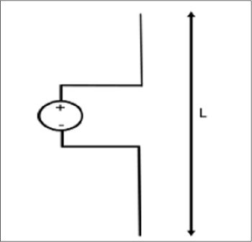

The circuit diagram of a short dipole with length L is shown. The actual size of the antenna does not matter. The wire that leads to the antenna must be less than one-tenth of the wavelength. That is

*L*<*λ*10

Where

* **L** is the length of the wire of the short dipole.
* **λ** is the wavelength.

Another type of short dipole is infinitesimal dipole, whose length is far less than its wave length. Its constructiion is similar to it, but uses a capacitor plate.

## Infinitesimal Dipole

A dipole whose length is far less than wavelength is **infitesimal dipole**. This antenna is actually impractical. Here, the length of the dipole is less than even fiftith part of the wavelength.

The length of the dipole, Δl << λ. Where, λ is the wavelength.

Δ*l*=*λ*50

Hence, this is the infinitely small dipole, as the name implies.

As the length of these dipoles is very small, the current flow in the wire will be dI. These wires are generally used with capacitor plates on both sides, where low mutual coupling is needed. Because of the capacitor plates, we can say that uniform distribution of current is present. Hence the current is not zero here.

The capacitor plates can be simply conductors or the wire equivalents. The fields radiated by the radial currents tend to cancel each other in the far field so that the far fields of the capacitor plate antenna can be approximated by the infinitesimal dipole.

## Radiation Pattern

The radiation pattern of a short dipole and infinitesimal dipole is similar to a half wave dipole. If the dipole is vertical, the pattern will be circular. The radiation pattern is in the shape of “**figure of eight**” pattern, when viewed in two-dimensional pattern.

The following figure shows the radiation pattern of a short dipole antenna, which is in **omni-directional pattern**.

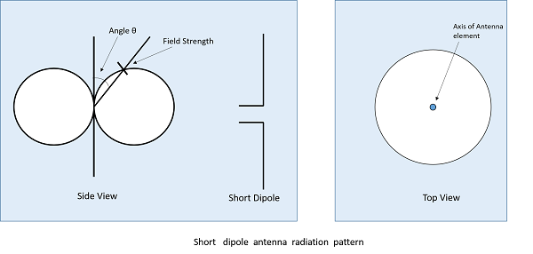

### Advantages

The following are the advantages of short dipole antenna −

* Ease of construction, due to small size
* Power dissipation efficiency is higher

### Disadvantages

The following are the disadvantages of short dipole antenna −

* High resistive losses
* High power dissipation
* Low Signal-to-noise ratio
* Radiation is low
* Not so efficient

### Applications

The following are the applications of short dipole antenna −

* Used in narrow band applications.
* Used as an antenna for tuner circuits.